Experiment 05
LAN Installation and Configuration

Objective:
To install and configure a Local Area Network (LAN) so that multiple computers can communicate and share resources within a limited area like a computer lab or classroom.

Prerequisites:
Before performing this experiment, students should have:
- Basic knowledge of computer networking.
- Understanding of network devices like switches, routers, cables, NIC.
- Awareness of IP addressing (IPv4).

What is LAN?
A Local Area Network (LAN) is a network that connects computers and devices in a limited geographical area, such as a room, building, or campus. It allows devices to share resources like files, printers, and internet connection.
Key Features of LAN:
- Covers small area (home, lab, office).
- High-speed communication (up to 1 Gbps).
- Allows file, printer, and internet sharing.
- Secure and easy to maintain.
Common LAN Devices:
Device | Function
NIC (Network Interface Card) | Allows computer to connect to the LAN
Switch | Connects multiple devices in the LAN
Router | Connects LAN to the internet (if needed)
Ethernet Cable | Physical medium for connection (Cat5e/Cat6)
RJ45 Connector | Connector at the end of Ethernet cables
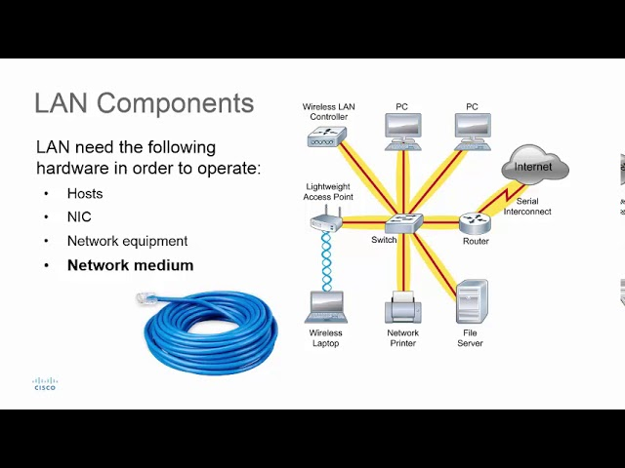

Apparatus Required:
- 2 or more Computers / Laptops
- Network Switch or Router
- Ethernet (LAN) Cables – Cat5e/Cat6
- RJ45 connectors
- Crimping Tool (optional)
- Power Source

Procedure:
Step 1: Setup Devices
- Place computers close to a switch or router.
- Plug the power supply for all devices.
- Check if all computers have working LAN ports and NIC drivers installed.

Step 2: Make the Connections
- Connect each computer to the switch/router using Ethernet cables.
- Ensure all cables are tightly plugged into the RJ45 port.
- Power on all devices.
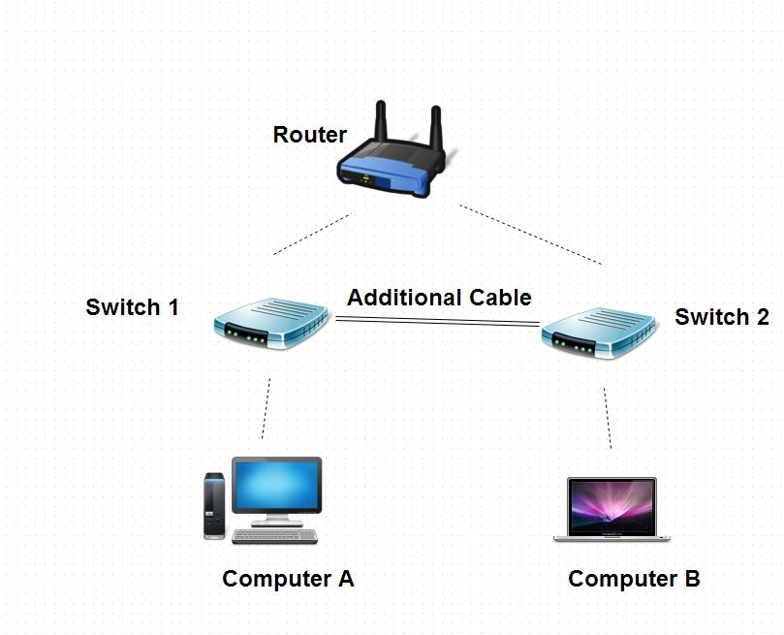
Step 3: Configure IP Addresses
Method 1: Static IP
- Go to: Control Panel → Network and Sharing Center
- Click: Change adapter settings → Right-click on Ethernet → Properties
- Select: Internet Protocol Version 4 (TCP/IPv4)
- Choose: "Use the following IP address"
  - IP Address: 192.168.1.X (X = 1,2,3…)
  - Subnet Mask: 255.255.255.0
  - Default Gateway: 192.168.1.1

🔸 Method 2: DHCP (Automatic IP)
- If using a router, enable DHCP.
- Computers will automatically receive IP addresses.

Step 4: Test LAN Connectivity
- Open Command Prompt on one computer.
- Type: ping 192.168.1.2 (another PC’s IP)
- If reply is received, LAN is working.
Reply from 192.168.1.2: bytes=32 time<1ms TTL=128
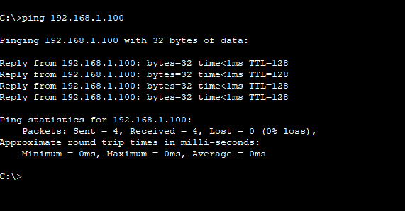

Step 5: File and Folder Sharing (Optional)
- Right-click any folder → Properties → Sharing → Share.
- Ensure network discovery and file sharing are enabled:
  - Go to: Control Panel → Network and Sharing Center → Advanced sharing settings.

Result:
Successfully configured a LAN network that enables communication between connected computers.

Conclusion:
From this experiment, we learned:
- How to set up a LAN using switch/router and Ethernet cables.
- How to assign IP addresses using static or DHCP methods.
- How to test network connectivity using the ping command.
- Basic resource sharing in a LAN.

Advantages of LAN:
Advantage | Explanation
High Speed | Fast data transmission within local area
Resource Sharing | Devices can share printers, files, internet
Low Cost | Economical setup and maintenance
Secure | Easier to manage and protect from outside access

